Transformation (Soul Matters Edition)
Covenant Group Session Plan
Greenville Unitarian Universalist Fellowship, Greenville, South Carolina
Based on material from Soul Matters-Small Group: The Gift of Transformation – March 2024
Compiled and adapted by Jim Hennigan, February 2024

Welcome, Chalice Lighting: Here we are, together in this space. By our love and by our covenant, we make this a holy place. We light the chalice of Unitarian Universalism in honor of the light that lives in each of us, the light that shines among us, and the light we bring into the world.

Personal Check In: Briefly share something from your life since we last met and how you are feeling now.

Opening Words: The gift of transformation bears down on us, shifting the trajectory of our lives, without pausing for consent, reflection, rest, or refreshment. It skates along delicately in our hearts at the speed of light. It trundles clumsily with the brutality of a glacier, toppling majestic mountains before carving out vibrant canyons. It arrives with the fanfare of the crowning of a regent and the furtiveness of farmland parching under a sweltering sun. It echoes as relentlessly as the hollow thud of the door slamming in the wake of a lover’s exit, yet it’s as quickly forgotten as the reason you walked into the room. It is as ancient and detached as the edges of the universe it birthed and as immediate and as personal as your next breath. Its most daunting feature is that each of us wields this power of transformation, free to point it inward, outward, or (perhaps most tragically) to not summon it at all. The full heft of the cosmos is an unassailable witness that transformation abides no master, yet its enduring presence begs us to study its footwork as that of our lifelong dance partner. – Jim Hennigan
Questions to prompt and guide discussion:
- Share a time when you underwent a significant change of your own making. What was the catalyst (a change of scenery, a new job, a major life event…)? How did you go about that process and what, specifically, did you desire to change? What changes lasted? What are some key takeaways from that “reinvention?”
- Share an experience of yours when you were part of an organization or group (e.g. work, social or church/fellowship) as it underwent a transformation (either by choice or by circumstance). How did the institutional transformation occur and what were some of the challenges you noticed? How did the collective experience transform you individually?
- When you (alone or with others) tried to change some external thing, how did the effort to change it bring about change in you? What were some of your feelings as you went about creating change? How did you address or embrace those feelings?
- If one (or more if you prefer) of today’s readings resonates with you, consider sharing that reading. What feelings arise from the reading? What has the reading helped you recall or revisit or understand in a new light? How does it help you better understand the role of “transformation” as a core spiritual value of our living tradition?
Readings – from the Common Bowl: The following pages with the readings are intended to be printed in duplex (or two-sided) mode and cut up as cards to be selected at random and read aloud by participants. You may assign readings if you prefer and/or decide how many readings to use during your time together to leave sufficient time for sharing and discussion. The fronts contain quotes and the reverse side offers context.
Sharing - This is a time to speak without interruption and for deep listening. Deep listening means no interrupting, no fixing, no saving, no advising, and no setting each other straight. Please share one or more responses to the session questions.
(After each person has shared once without cross-talk, this can be a good time to take a brief break)
Open Discussion - This is a time to respond to something another person said about the topic or to relate additional thoughts that may have occurred as others shared their thoughts on this topic. Continue to practice deep listening.

Closing reading: "As for the future, your task is not to foresee it, but to enable it." – Antoine de Saint-Exupéry (1900-1944), French aviator and author, in The Wisdom of the Sands (1948).
Announcements / Plans / Personal Check Out
Extinguish the Chalice We extinguish this flame but not the light of truth, the warmth of community, or the fire of commitment. These we carry in our hearts until we meet again.
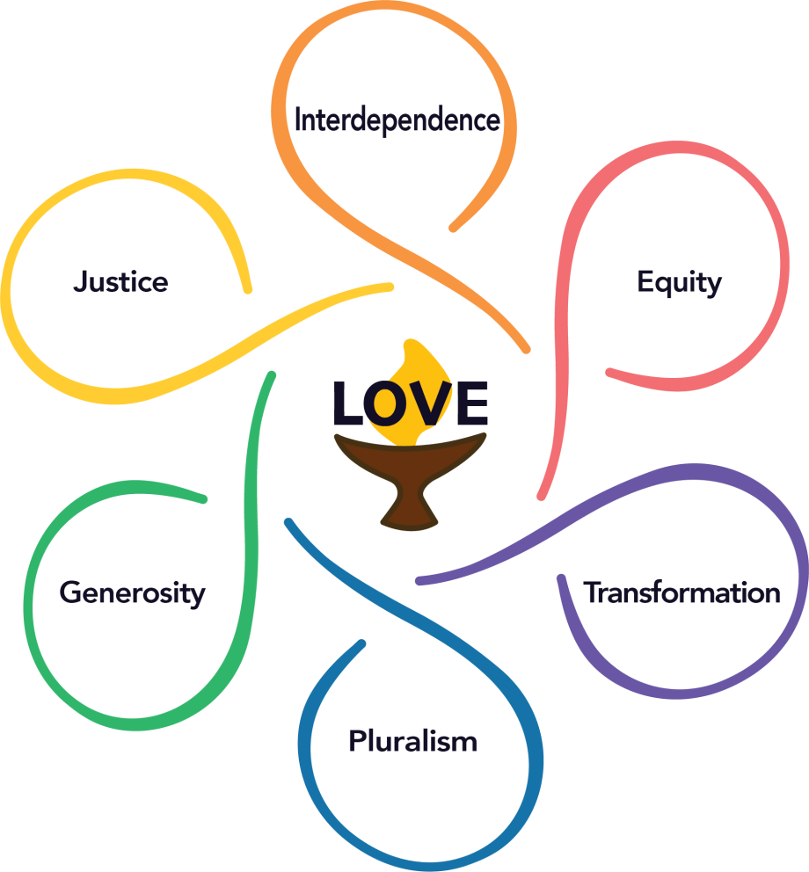

Transformation - We adapt to the changing world.
We covenant to collectively transform and grow spiritually and ethically. Openness to change is fundamental to our Unitarian and Universalist heritages, never complete and never perfect.
And the day came when the risk to remain tight in a bud was more painful than the risk it took to blossom. – Elizabeth Appell | Let difficulty transform you. And it will. In my experience, we just need help learning how not to run away. – Pema Chödrön
The trouble with steeling yourself against the harshness of reality is that the same steel that secures your life against being destroyed secures your life also against being opened up and transformed by the holy power that life itself comes from. – Frederick Buechner | I am no longer accepting the things I cannot change. I am changing the things I cannot accept. – Angela Davis
This I now know for certain: I do all of growing during the times in my life when I am offering compassion to the parts of myself that have not yet grown. I never once managed to shame myself into a version of me I loved more. – Andrea Gibson | What happens to one, happens to us all.  We can starve together or feast together.  All flourishing is mutual. – Robin Wall Kimmerer
Personal growth is not about amassing knowledge, it's about becoming more conscious, … more mindful of inner knowing. – Peter Shepherd | What is defeat? Nothing but education. Nothing but the first step to something better. – Wendell Phillips
If you want to change the world, first, be sure you are changing yourself. Be tender. Be kind. Be at peace. Be all the things you wish for. Be your own better self. – Rev. Sean Parker Dennison | Watch yourself about complaining. What you’re supposed to do when you don't like a thing is change it. If you can’t change it, change the way you think about it. – Maya Angelou

Pema Chödrön is an American Tibetan-Buddhist. She is an ordained nun, former acharya of Shambhala Buddhism and disciple of Chögyam Trungpa Rinpoche. Chödrön has written several dozen books and audiobooks and is principal teacher at Gampo Abbey in Nova Scotia. This quote comes from When Things Fall Apart (1996). | This quote is frequently attributed to Anaïs Nin yet nowhere does anyone pinpoint just where in her complete works this poem can be found. It’s credibly claimed by Elizabeth Appell who says the poem, “Risk!” was composed in 1979 as an inspirational and motivational passage for students at the night-university she worked for at the time.
Angela Yvonne Davis is an American Marxist and feminist political activist, philosopher, academic, and author; she is a professor at the University of California, Santa Cruz. Davis was a longtime member of the Communist Party USA and a founding member of the Committees of Correspondence for Democracy and Socialism. | Frederick Buechner (1926-2022) was an author, Presbyterian minister and theologian. This passage is from his first memoir The Sacred Journey (1982). In this passage he recalls his family’s decision to move to Bermuda following his father’s death. His grandmother disapproved, asking the family to come to grips with reality.
Robin Wall Kimmerer is a mother, scientist, SUNY professor, and enrolled member of the Citizen Potawatomi Nation. She is the author of Braiding Sweetgrass: Indigenous Wisdom, Scientific Know-ledge and the Teachings of Plants (2010), the source of this quote. She founded and directs the Center for Native Peoples and the Environment. | Andrea Gibson is a young poet and activist in Colorado who is battling cancer. This passage is from a Substack post - https://andreagibson.substack.com/p/cancer-journey-selflove-transformation dated January 11, 2024, where she reflects on her cancer journey and how it shapes the changes in her life.
Wendell Phillips (1811-1884), a Massachusetts lawyer, abolitionist, advocate for Native Americans, and an early supporter of women’s rights, included this hopeful comment as part of his remarks on the failed raid at Harper’s Ferry by John Brown in an 1860 book entitled The John Brown Invasion: An Authentic History of the Harper’s Ferry Tragedy. | Peter Shepherd is an author, blogger, podcaster and former civil engineer who spends his time now exploring Eastern thinking, particularly with a view toward inner change and mindfulness.
Maya Angelou (1928-2014) shared this in Wouldn’t Take Nothing for My Journey Now (1993), a memoir of her collected wisdom and a celebration of the written and spoken word that she mastered over her long Pulitzer Prize-winning career. | Rev. Sean Parker Dennison is a UU minister in Oregon and a co-founder of TrUUst. This verse is from the meditation “Letter from Our Better Angels” which is available in Breaking and Blessing (2020), a collection of their meditations.

No transmutation without fire… the self must lose to find and die to live. – Evelyn Underhill | Ours is not the task of fixing the entire world all at once, but of stretching out to mend the part of the world that is within our reach… What is needed for dramatic change is an accumulation of acts, adding, adding to, adding more, continuing. We know that it does not take everyone on Earth to bring justice and peace, but only a small, determined group who will not give up during the first, second, or hundredth gale… -- Dr. Clarissa Pinkola Estés
If you see what needs to be repaired and how to repair it, then you have found a piece of the world that God has left for you to complete. But if you only see what is wrong and what is ugly in the world, then it is you yourself that needs repair. – Rabbi Menachem Mendel Schneersohn | All that you touch you change.  All that you change changes you.  The only lasting truth is change…  God is change. – Octavia Butler
Time won't fly, it's like I'm paralyzed by it  I'd like to be my old self again / But I'm still trying to find it  After plaid shirt days and nights when you made me your own  Now you mail back my things and I walk home alone  But you keep my old scarf from that very first week  'Cause it reminds you of innocence  And it smells like me / You can't get rid of it  'Cause you remember it all too well, yeah – Taylor Swift | To stay committed to this work, I have learned to accept the constant experience of entrenchment and transformation. On the bad days, when entrenchment is lashing out, tearing down, pretending you don’t have a name, this work feels soul crushing, dehumanizing. But on the good days, you witness transformation, openness, a willingness to change one’s worldview. And, for a brief moment, I can believe in the possibility that we are still inching toward justice. – Austin Channing Brown
Oh, mirror in the sky, what is love?  Can the child within my heart rise above?  Can I sail through the changin' ocean tides?  Can I handle the seasons of my life?  Well, I've been afraid of changin'  'Cause I've built my life around you  But time makes you bolder, Even children get older  And I'm getting older too. — Stevie Nicks | When I was a young boy I had visions of fame  And they were wild and they were free  They were blessed with my name  And then I grew older and I saw what's to see  That the world is full of pain and my dreams they left me  And then I got stronger and tired of the pain  That's when I picked up the pieces and I regained my name. – Black Men United (D’Angelo)
It is ‘in the going toward’ that salvation can be found…. To be vulnerable, to tend and to love, to rip off the mask that blinds us to the beauty of the human being right in front of us. To recognize …the disfiguring effect of hatred and fear, and the exacting power of love. – Eddie S. Glaude, Jr. | Impossible is just a big word thrown around by small men who find it easier to live in the world they’ve been given than to explore the power they have to change it. Impossible is not a fact. It’s an opinion. Impossible is not a declaration. It’s a dare. Impossible is potential. Impossible is temporary. Impossible is nothing. — Muhammad Ali

Dr. Clarissa Pinkola Estés is an American Mestiza Latina, poet, activist, and Jungian psychoanalyst. She is the author of Women Who Run with the Wolves (1996). This quote comes from an undated but frequently reproduced comment entitled “You Were Made For This: Letter to a Young Activist During Troubled Times.” | This quote is from Evelyn Underhill (1875-1941) in her novel Mysticism (1911). Underhill was a prolific author and, at heart, a theologian, having taken a far-ranging, sometimes meandering – yet always highly intentional – path that was always very much visible in her characters and in the forces that animated them for her readers.
Octavia Butler is a renowned author who has overcome endless microaggressions and other obstacles on account of her being Black and female while writing most frequently in a genre (science fiction) often claimed as a male domain. These words are the opening to her her classic novel Parable of the Sower (1993). | The Hebrew principle of “Tikkun Olam” refers to repairing the world, which – in more progressive circles – amounts to a command to make the world more just. There are many rabbis who will offer the first part of this quote. The twist here is Rabbi Schneersohn’s observation about those who may be too “gung ho,” suggesting that the transformation they seek may not be ethical.
This quote comes from Austin Channing Brown’s New York Times bestseller I’m Still Here (2018) in which Brown details the fatigue of being in a world that constantly centers everything on the needs and viewpoints and caring of white people, often as though Black people are mere foils or inanimate objects interacting with white people. | Taylor Swift, sings this in “All Too Well” from her album, Red (2012), which she associates with autumn, a season marked by change. “All Too Well” for her, captures the idea of change because, as she said at her Tiny Desk Concert, the meaning of the song was changed by the audience reception and connection to it.
Black Men United is a supergroup of Black male R&B artists who came together in 1994 for one song, “U Will Know,” which spoke to the trans-formational healing and empowerment that comes from being together in community. The lyrics here, mostly written by D’Angelo, are focused on how this wisdom is the byproduct of time, setbacks, and a resolve to do better. | Stevie Nicks wrote “Landslide” in Aspen in 1973 at a time when she wondered if she had a future in music or if she’d spend her life waiting tables and cleaning houses. Her partner was on the road trying to work out his own music career and she was left behind for several months, staring at the mountains. Writing “Landslide” was her way of saying, “we’re going to the top.”
Muhammad Ali (1942-2016) was ever the embodiment of transformation. He accepted it and signaled it in his name change which, in turn, created transformation as people reacted to it. He transformed the sport of boxing. He transformed the interplay between sport and politics. He transformed a few boxers’ noses, too. | Eddie S. Glaude, Jr is an American academic, author, and current-affairs pundit. This quote comes from his bestselling book We Are The Leaders We Have Been Looking For. He pinned this quote to the top of his Twitter (or X) social media account.

If we say “inclusion” but we mean “We have something that’s perfect exactly the way it is,  so you should come join us and fit right in,“  that’s not inclusion, that’s colonization…. People who join an organization or group should not be expected to leave their whole selves at the door and Become Just Like Us. – CB Beal | The world as we have created it is a process of our thinking. It cannot be changed without changing our thinking. ― Probably Not Albert Einstein
We must…create the kind of tension in society that will help men to rise from the dark depths of prejudice and racism to the majestic heights of understanding and brotherhood. – Martin Luther King, Jr. | The function of prayer is not to influence God, but rather to change the nature of the one who prays. ― Søren Kierkegaard
You know, when I was nineteen, Grandpa took me on a roller coaster. Up. Down. Up. Down. Oh, what a ride! I always wanted to go again. You know, it was just so interesting to me that a ride could make me so frightened, so scared, so sick, so excited, and so thrilled all together! Some didn't like it. They went on the merry-go-round. That just goes around. Nothing. I like the roller coaster. You get more out of it. – Grandma (played by Helen Shaw) in Parenthood (1989) | The world doesn’t change one person at a time. It changes as networks of relationships form among people who discover they share a common cause and vision of what’s possible. – Margaret Wheatley and Deborah Frieze
Joy is an act of resistance. – Toi Derricote | Personal transformation can and does have global effects. As we go, so goes the world, for the world is us. The revolution that will save the world is ultimately a personal one. – Marianne Williamson
You never change things by fighting the existing reality. To change something, build a new model that makes the existing model obsolete – Buckminster Fuller | When we quit thinking primarily about ourselves and our own self-preservation, we undergo a truly heroic transformation of consciousness. – Joseph Campbell

Albert Einstein (1879-1955) gets credit for this, but it’s not published in any context. Was it in a speech, a pamphlet he wrote, a lecture he gave? The earliest recorded mention of this is around 1970 – fifteen years after Einstein’s death. It’s a nifty idea all the same, so was it worth including in this month’s compilation of readings? | CB Beal is a white, non-binary/genderqueer, queer, mostly able-bodied fat Unitarian Universalist minister who facilitates learning experiences across the denomination (and beyond) on issues of marginalization, oppression, and privilege. In this 2022 blog entry they share how transformation is worthy of being elevated as a UU value only when it occurs ethically.
Søren Kierkegaard (1813-1855) was a Danish existentialist philosopher. Here he observes the audacity of a human who imagines that they can get God to do something that accedes to the wishes of the mere mortal. This concept of prayer – a commonly-held one – was so amusing to Kierkegaard that prayer only made sense if it was served with a healthy portion of humility. | Martin Luther King, Jr. (1929-1968) scribbled his renowned essay, “Letter From Birmingham City Jail” along the margins of newspapers smuggled in to him, defending his campaign tactics to eight faith leaders of predominantly white churches. First printed in The Atlantic in 1963, the letter began transforming King’s image from race baiting troublemaker to holy leader.
Margaret Wheatley and Deborah Frieze lead the Berkana Institute (berkana.org) which offers training and resources for activist leaders grounded in Eastern philosophy and feminist principles. This quote comes from a paper they co-authored called “Using Emergence To Take Social Innovation To Scale.” | The actress Helen Shaw (1897-1997), playing a character that is dismissed as being “batty” and daft, offering non sequiturs that kill lively conversation, drops into a scene near the end of the movie Parenthood to share a memory that seems unrelated to anything, until it’s revealed as wisdom on the turmoil of life.
Marianne Williamson is an author, speaker, spiritual leader and a 2024 candidate for U.S. President. She is a founder of Project Angel Food and The Peace Alliance. This quote comes from her 2013 book, Illuminata. | Toi Derricote is a poet and memoirist, having published seven compilations of poetry. This quote is a favorite of Austin Channing Brown who reads into it a subversive element of trans-formation – as joy, to fascists and white supremacists, is a repudiation of their best efforts. Transformation springs from resistance.
Joseph Campbell (1904-1987) was an author and mythologist – a keeper of human mythology, A posthumously released documentary series with Bill Moyer and a companion book, The Power of Myth (1988) – in which Campbell elaborated on the common elements of the hero’s journey throughout literature, regardless of culture. | Buckminster (or Bucky) Fuller (1895-1983) was an architect by trade…and as a philosopher and futurist he was something of an architect of change in systems, from health, housing, war, overpopulation, inflation, energy conservation and more. This quote comes from A Fuller View (2012) a collection of his ideas as annotated by numerous present-day architects of change.

